**ABSTRACT**

The corona viruses are spread through contact or touch. The virus has been spread all around at global level. In order to prevent from this contagious disease, SOPs should be followed. The major rule is to wash your hands for at least 20 seconds, for this purpose we have developed an IoT based system that is touch-less and provides many facilities. The system is able to detect human hands and automatically sanitize his/her hands. The system uses touch-less thermometer that calculates human body temperature and decides whether to open the door or not. Additionally the system also tells about the quantity of sanitizer through mobile application. These Days, Internet of Things (IoT) has been emerged in all aspects of our daily life. It has wide implications in home, cities and industries. IoT takes advantage of identification, data capture, processing, and control devices through web application and android, and communication capabilities of modern technology to allow regular machines to provide new data sources. The system was tested successfully after implementation. All the sensors are working properly according to the approximation. This is helpful in order to prevent humans from corona virus (COVID-19).

**IOT Circuit Design**

**NodeMCU with Ultrasonic Sensor**

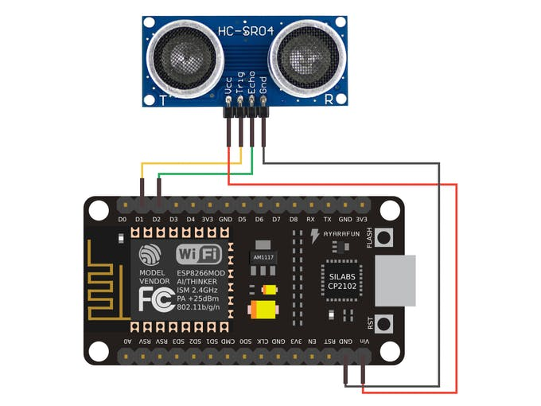

Figure 1: Module 1

**Arduino with Thermometer, Buzzer, Ultrasonic Sensor, LCD, Door lock and relay**

.

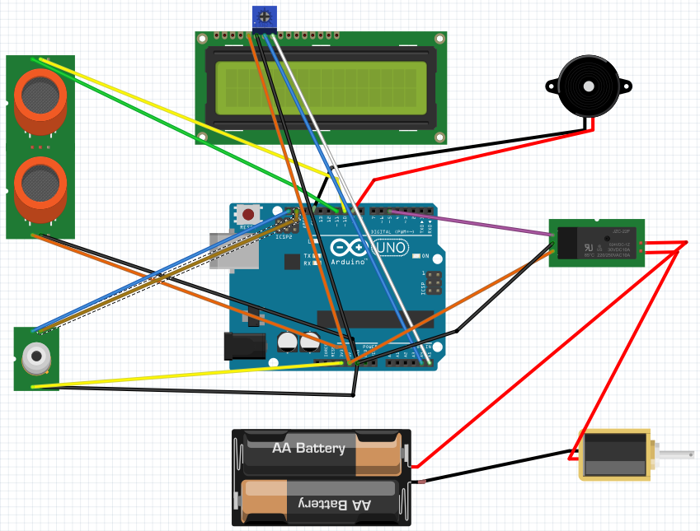

Figure 2: Module 2

**Arduino nano With Water Pump, Relay & IR Sensor**

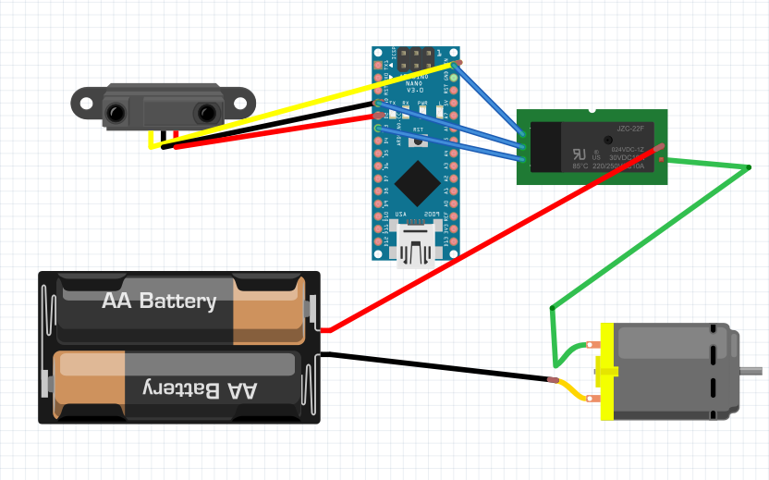

Figure 3: Module 3

**5.2 Android Application**

The following are screens of our android application

**5.2.1 Main Screen:**



Figure 4: Main Screen

**5.2.4 Project create**

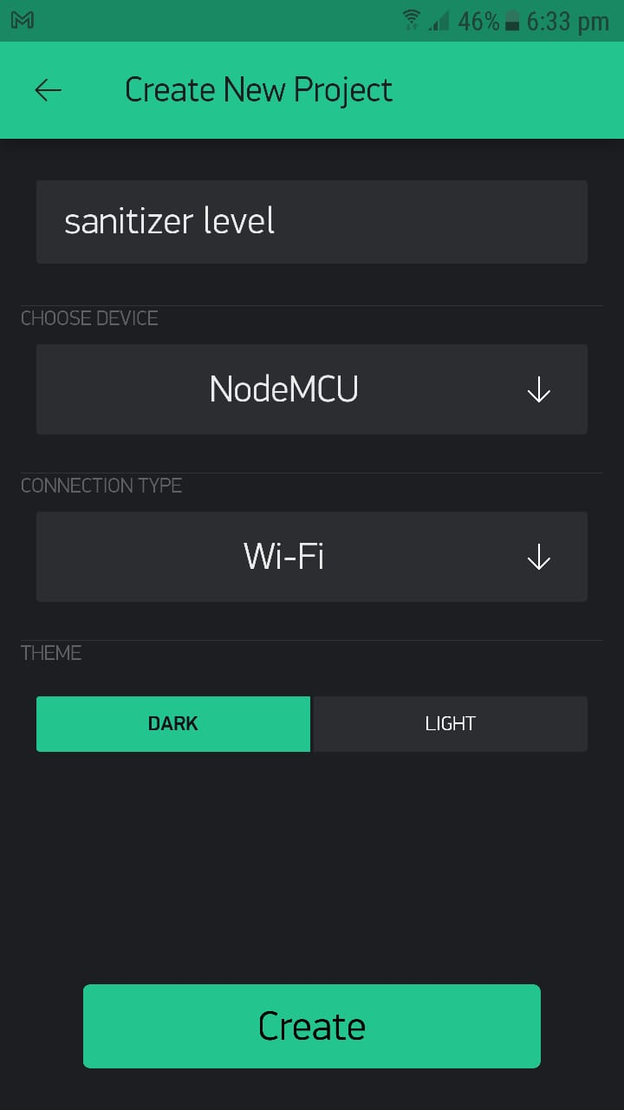

Figure 5: Project create

**5.2.3 Authentication**

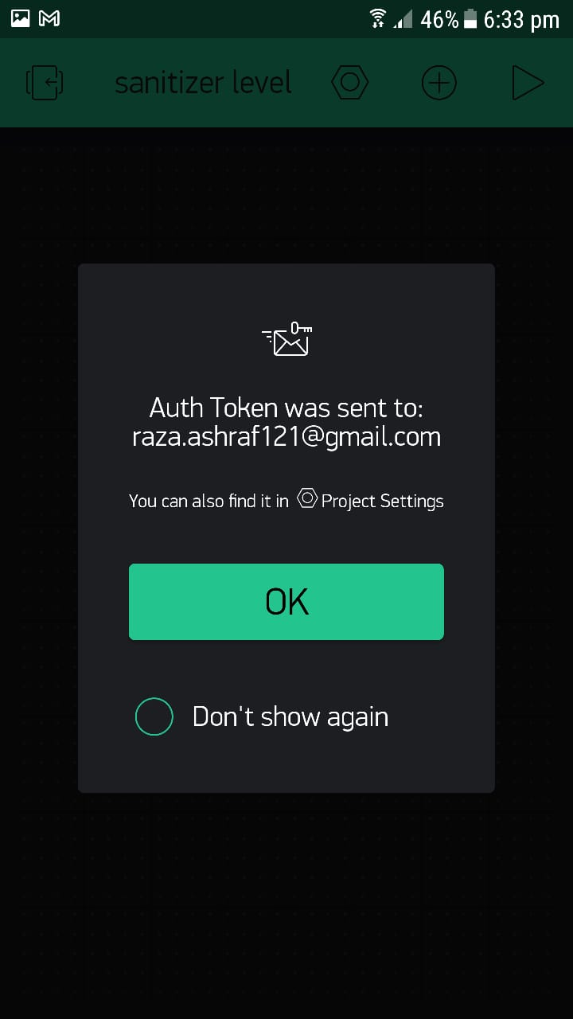

Figure 6: Authentication

**5.2.2 Settings**

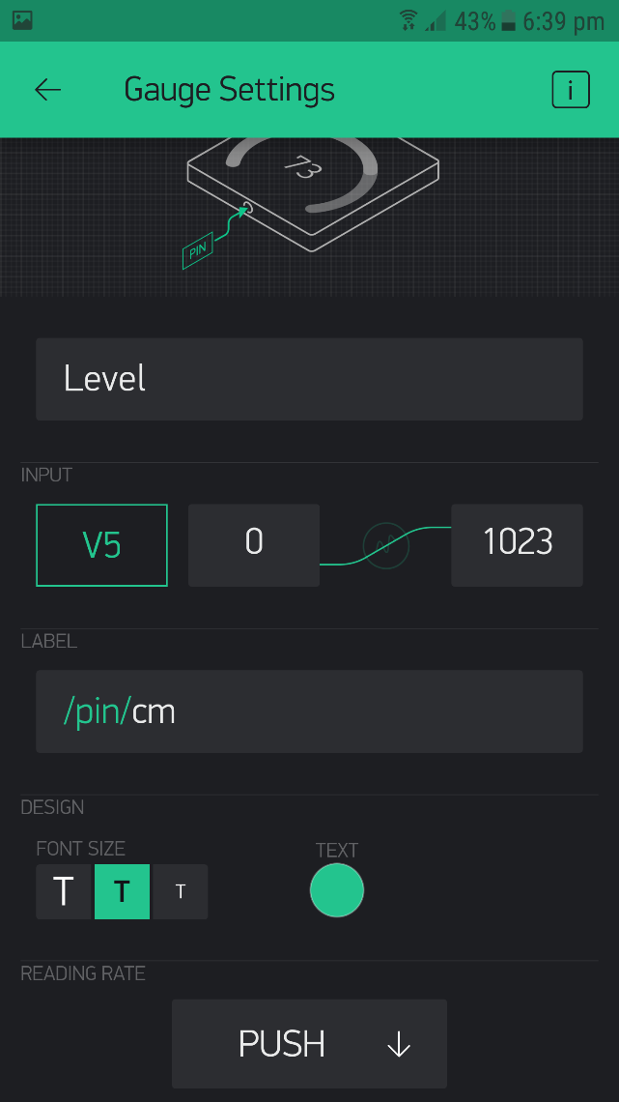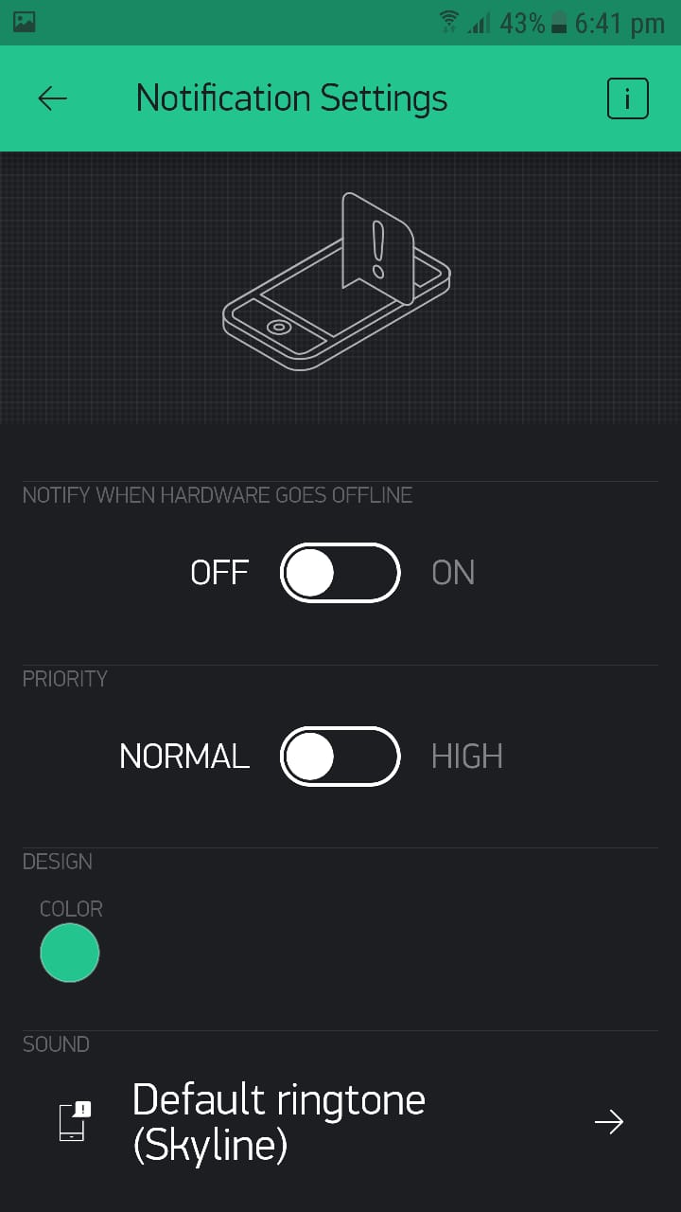

Figure 7: Settings Figure 8: Settings

**Conclusion**

The core objective of project was achieved successfully. All the sensors were first tested individually and then merged together to give final results. The project is user-friendly, easy to implement. It is flexible and cost effective. It is the project whose working is real time. The system surely help in implementing the hand hygiene without any challenges as it is a must to sanitizer if you are to access any entry point. It is much safer and more recommended due to its touch less property which zeros down any chances for cross contamination. The IoT is growing steadily. It has covered a wide area of application. The IoT has been emerged on social media at economic level. Products, machinery, smart home, smart cities, smart health care system, smart grid system and many more fields has broadly implemented the IoT. The IoT is sensor-based technology that receives data from environment and sends to cloud that can be accessed via mobile phone or desktop application to take an appropriate action or analysis to predict future variables. The devices based on IoT can also be automated in many fields like home automation, cargo warehouse automation, production automation etc. With the innovation in internet of Things (IoT) it will be incredible change in industrial automation. This is made possible due to recent developments in IoT that enables us to interact, communicate and control over wide area with the help of wireless wide area networks.

**Future Work**

After the successful implementation of this project, the following features will be add for the future work:

1. Facial Recognition System Integrated with this system to mark attendance of faculty members.
2. The system will also be able to save the body temperature of faculty members through attendance and check faculty member is vaccinated or not.